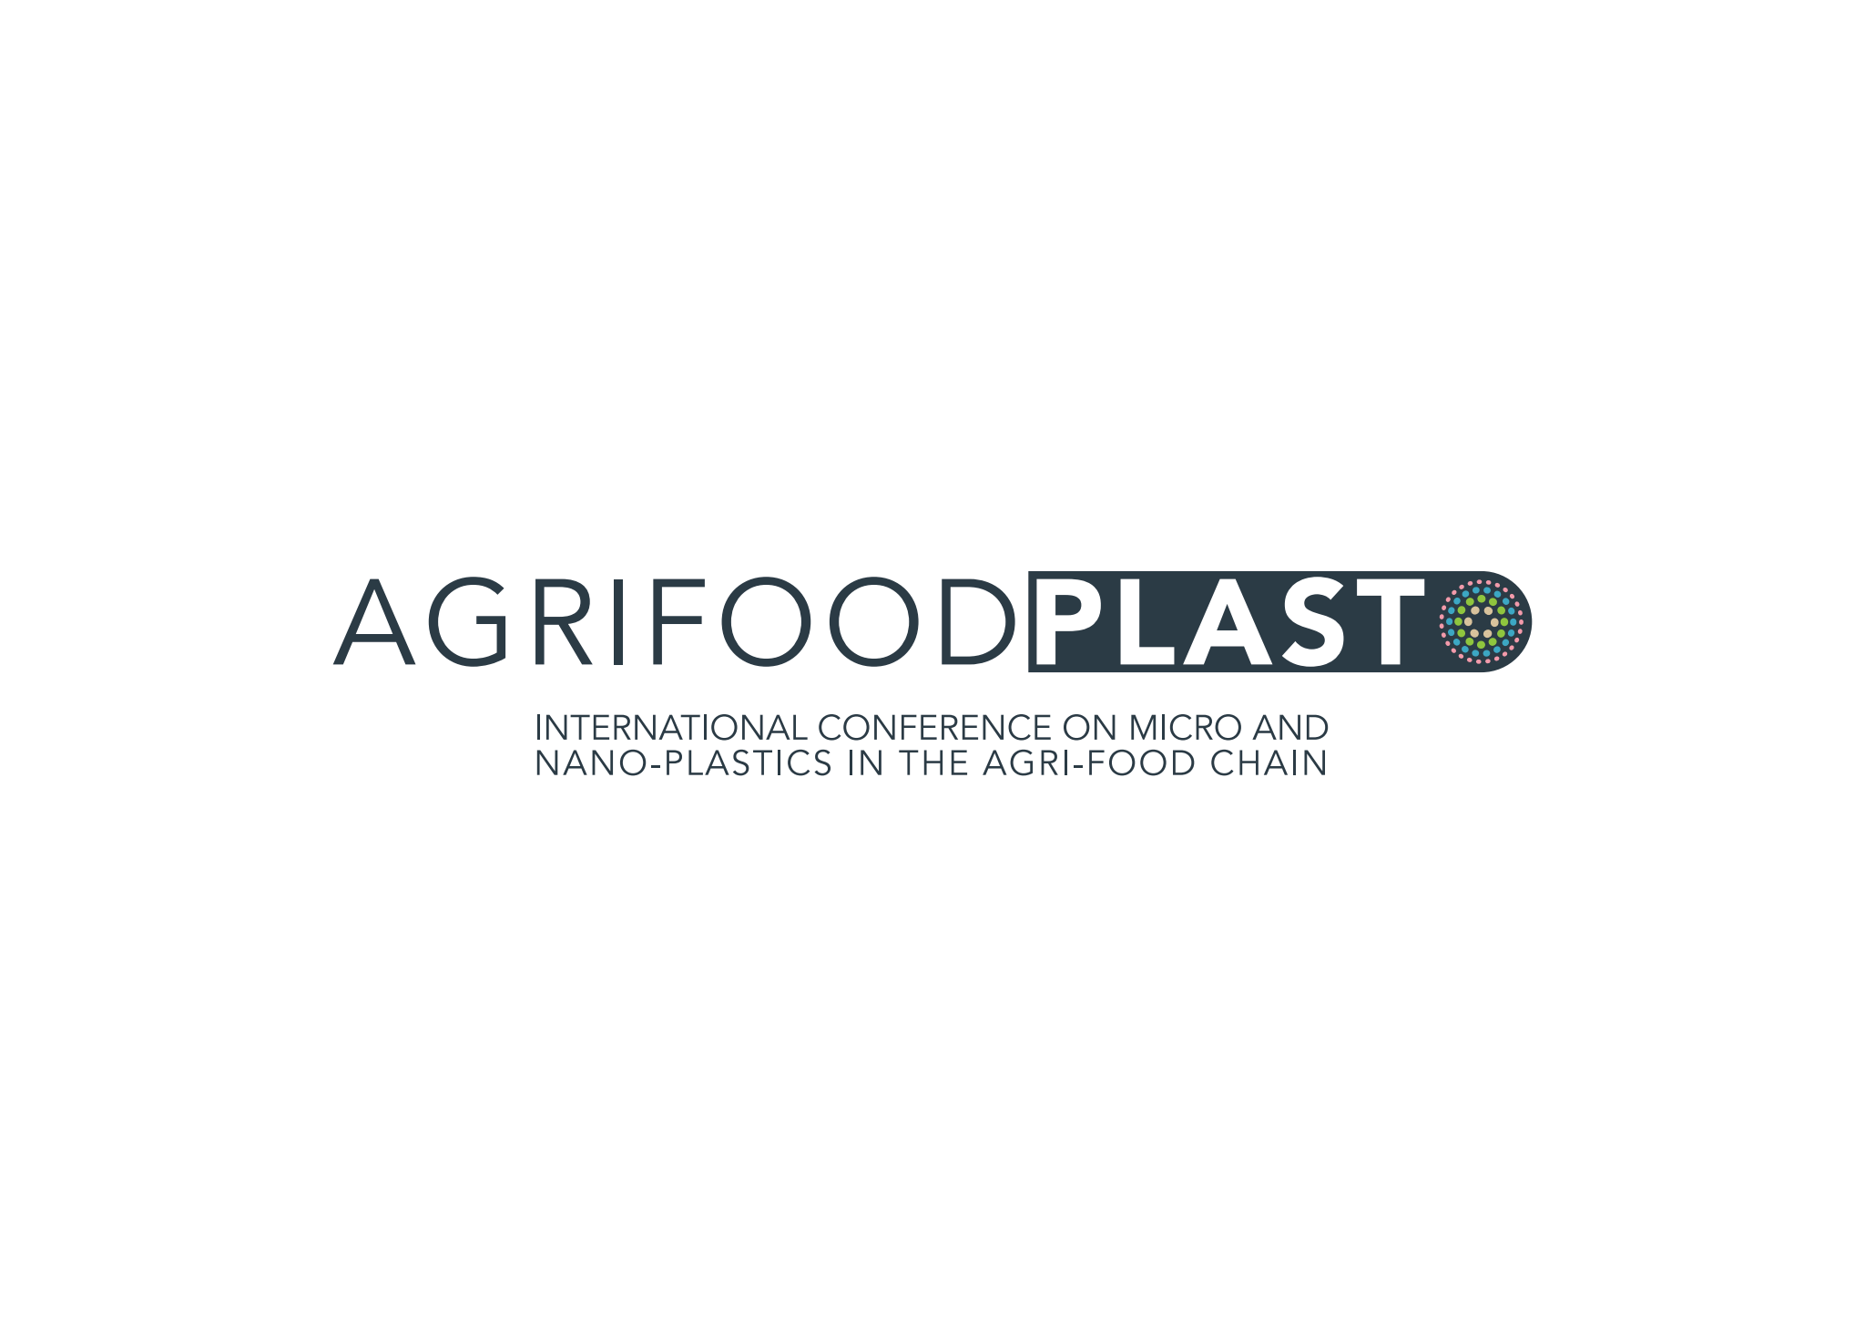

# **ABSTRACT TEMPLATE**

**Preferred presentation type (oral/poster):**

This is a text example. (Calibri, 11pt)

**Session:**

This is a text example. (Calibri, 11pt)

**Title:**

**This is a title example. (Calibri, 14pt Bold)**

**Authors and affiliations:**

**First Author1, Second Author1, Third Author2, Fourth Author2, Fifth Author3 (Calibri, 11pt bold)**

1 Example University 1 (Calibri, 11pt)

2 Example University 2 (Calibri, 11pt)

3 Example University 3 (Calibri, 11pt)

**Presenting author:**

Example Author (Calibri, 11pt)

**Abstract:**

*The abstract should be written in English. Max length: 250 words.*

**Please email the completed form to: info@agrifoodplast.eu**